Task 4: Password Security & Authentication Analysis

STEP 1: Learn How Passwords Are Stored
Hashing vs Encryption
Hashing
- One-way process
- Cannot be reversed
- Same input → same output
- Used for storing passwords
Encryption
- Two-way process
- Can be decrypted using a key
- Used for protecting data, not passwords

STEP 2: Identify Different Hash Types
🔹 MD5
- Produces a 32-character hexadecimal hash
- Contains letters (a–f) and numbers (0–9)
- Very fast hashing algorithm
- Not salted
🔹 SHA-1
- Produces a 40-character hexadecimal hash
- Contains letters (a–f) and numbers (0–9)
- Faster than secure standards
- Not salted
🔹 bcrypt
- Produces a variable-length hash (usually ~60 characters)
- Hash starts with $2a$, $2b$, or $2y$
- Salt is built-in
- Uses cost factor (slow hashing)

STEP 3:Generate Password Hashes
3.1 Generate MD5 Hash
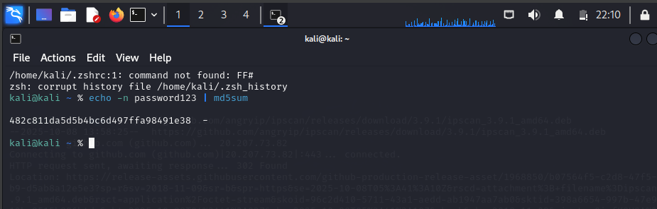

3.2 Generate SHA-1 Hash
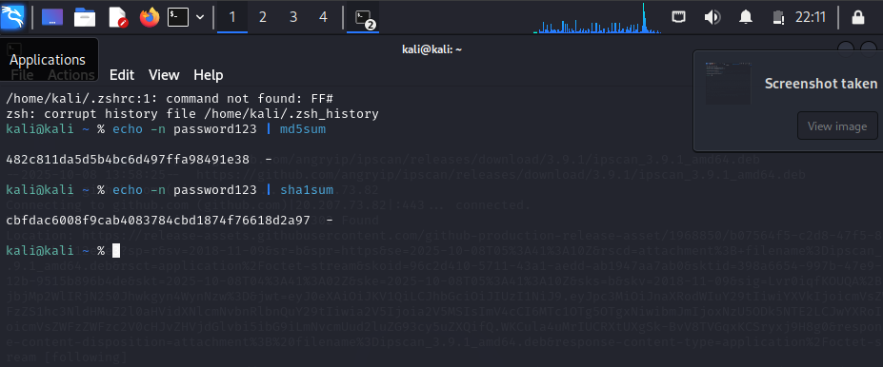

3.3 Generate SHA-256 Hash
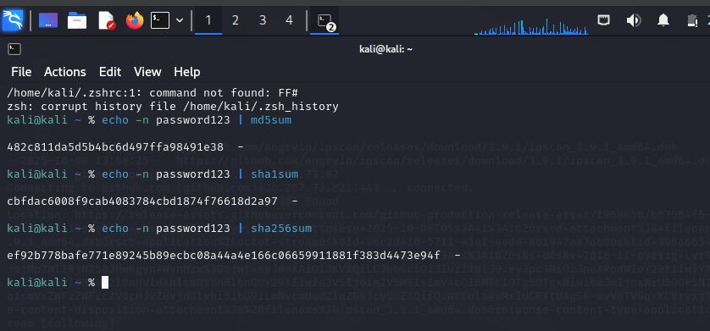

3.4 Generate bcrypt Hash
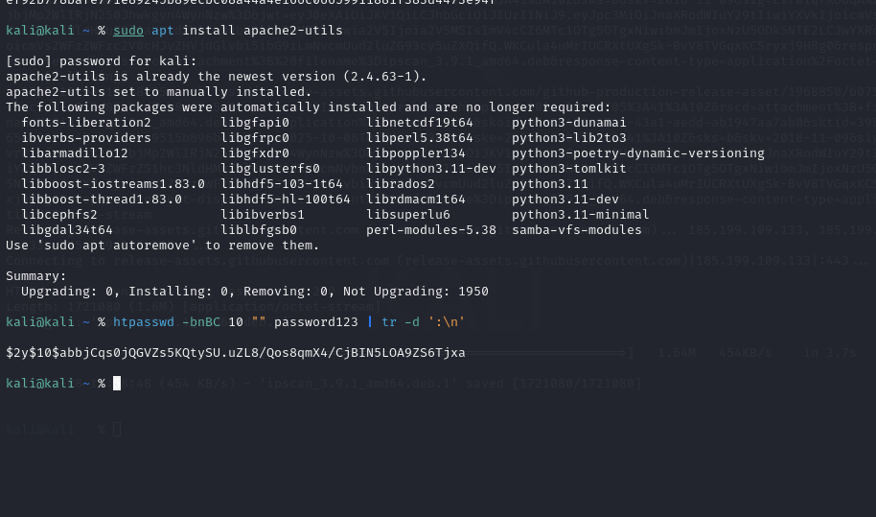
Save Hashes to a File
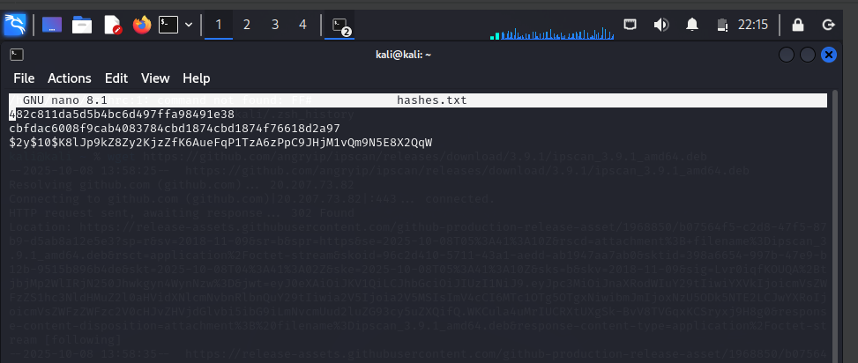
3.5 Identify Using Hashcat
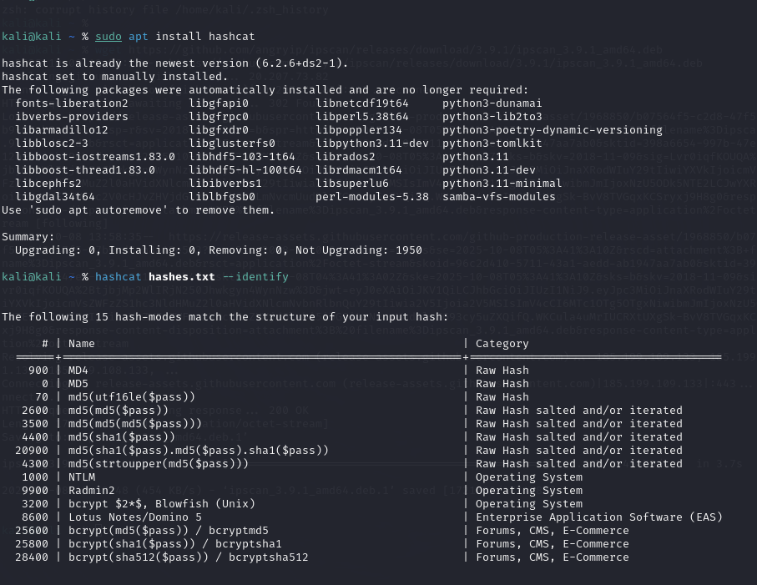

3.5 Identify Using John the Ripper
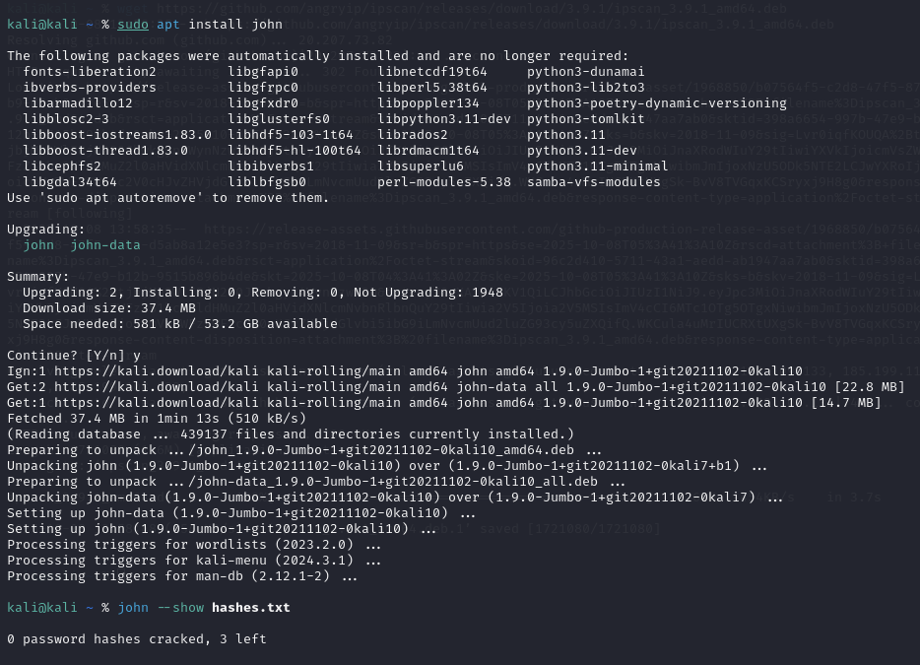
Step 4: Cracking Weak Hashes Using Wordlists
STEP 4.1: Prepare the Hash File
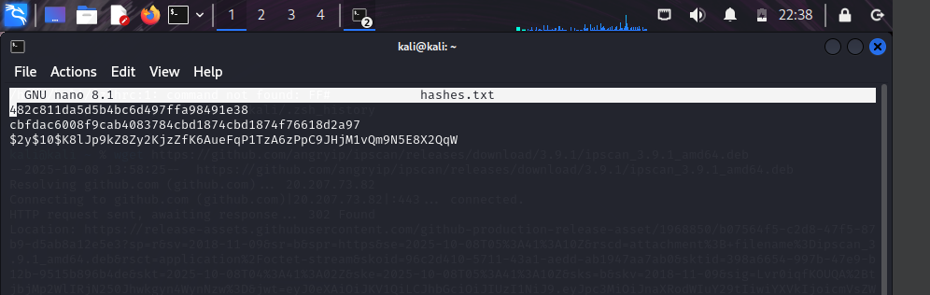
STEP 4.2: Locate a Wordlist
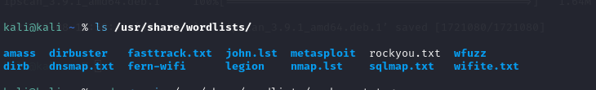

STEP 4.3: Crack MD5 Hash Using Hashcat
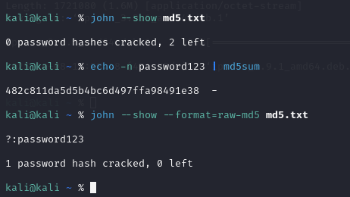
STEP 5: Understand brute force vs dictionary attacks
Dictionary Attack
- Uses a predefined wordlist (e.g., rockyou.txt)
- Very fast against weak passwords
- You demonstrated this practically using John
Brute Force Attack
- Tries all possible combinations
- Slower but guaranteed eventually
- More effective against short passwords

STEP 6: Analyze Why Weak Passwords Fail
- Short length (less than 8 characters)
- Common words (password, admin)
- Predictable patterns (123, @2024)
- No symbols or complexity
- Reuse across multiple platforms

STEP 7: .Study MFA and its importance.
What is MFA?
Using more than one authentication factor:
- Something you know (password)
- Something you have (OTP, phone)
- Something you are (biometric)

Why MFA is important:
- Stops attacks even if password is cracked
- Prevents credential stuffing
- Protects against phishing

STEP 8: Write Security Recommendations
Strong Password Practices
- Minimum 12–16 characters
- Mix of upper/lowercase, numbers, symbols
- Avoid dictionary words
- Unique password per service
- Use password managers
Authentication Best Practices
- Use bcrypt / Argon2 hashing
- Enable MFA everywhere
- Apply account lockout policies
- Monitor failed login attempts

